Задача 1:

#include <iostream>  
#include <windows.h>  
using namespace std;

int main() {  
    MessageBox(NULL, TEXT("Hello, World!"), TEXT("My Message Box"), MB_OK);  
    return 0;  
}

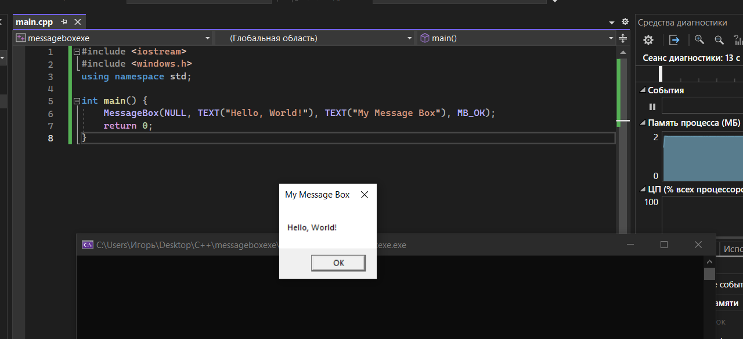

Задача 2:

2.1 Преобразуем основной исполняемый файл (MessageBoxExe.exe)

#include <iostream>

#include <windows.h>

using namespace std;

int main() {

HINSTANCE hMessageLib = ::LoadLibraryW(L"MessageLib.dll");

if (!hMessageLib) {

std::cout << "Cannot Load DLL" << std::endl;

return -1;

}

MessageBox(NULL, TEXT("Hello, World!"), TEXT("My Message Box"), MB_OK);

return 0;

}

2.2 Создадим dll (MessageLib.dll)

#include "MessageLib.h"

BOOL APIENTRY DllMain(HMODULE hModule,

DWORD ul_reason_for_call,

LPVOID lpReserved

)

{

switch (ul_reason_for_call)

{

case DLL_PROCESS_ATTACH:

::MessageBoxW(NULL, L"Hello from Dllmain MessageLib", L"MessageLib", 0);

case DLL_THREAD_ATTACH:

case DLL_THREAD_DETACH:

case DLL_PROCESS_DETACH:

break;

}

return TRUE;

}

int print_hello() {

::MessageBoxW(NULL, L"Hello from print_hello", L"MessageLib", 0);

return 0;

}

2.3 Создадим заголовок (messagelib.h)

#pragma once

#include <Windows.h>

#include <stdio.h>

#include <string>

extern "C" __declspec(dllexport) int __stdcall print_hello();

